GenSTEAMers | Chatting with AI | Modular Pathway
CORE 3 Option A - Scratch Peer Testing and Revision-Decision Guide
Testing, Improving and Reflecting
Fully supported implementation pathway

Purpose of this guide
This guide gives teachers a concrete, classroom-ready procedure for independently testing a CORE 2 Scratch chatbot, using peer evidence to choose Improve or Keep as designed, and documenting the correct verification test.
Core rule
Leave the Scratch project on its original device. Paired groups exchange seats for testing, then return to their own project for the revision decision. Change a feature only when the evidence justifies it; otherwise keep it and confirm the decision.

What counts as a successful CORE 3 Scratch outcome?
· two mandatory peer tests: the CORE 1 principle test and one Fresh User Challenge;
· one specific strength supported by a test result;
· one key finding supported by evidence;
· one revision decision: improve one relevant Scratch feature or keep it as designed;
· one matched verification test;
· one honest final judgement about the CORE 1 principle and remaining limitations.

Teacher preparation before the lesson
Preparation | Teacher check
Open projects | Click the green flag and confirm the menu appears. Test inputs 1, 2, 3 and one unsupported input.
Save method | Confirm how students will save or export the revised .sb3 file.
Pairing | Pair groups before the lesson and plan a clear direction for station exchange.
Evidence | Print/share one CORE 3 Test-Decide-Confirm Card per group. Keep creators’ internal mini-test records out of view during peer testing.
Privacy | Crop browser bars and account names from any screenshots.
Fallback | Keep the CORE 2 design plan available so the logic can be simulated on paper if needed.

Scratch prototype orientation
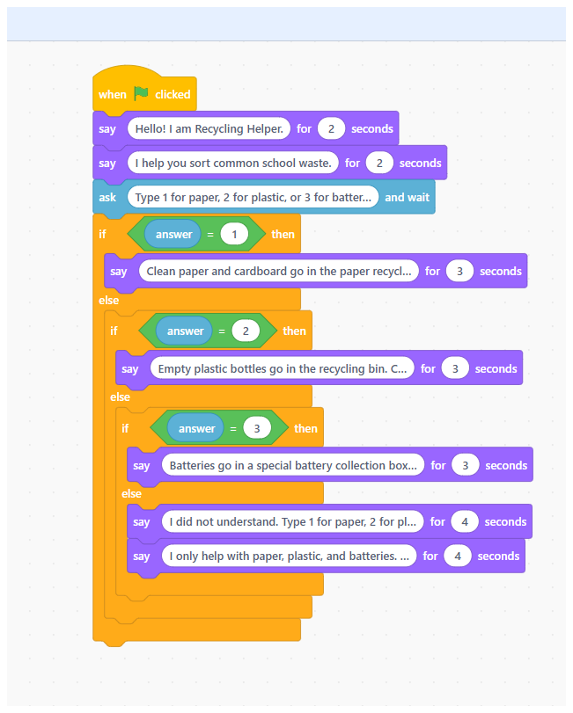
Figure 1. Complete menu-based Scratch chatbot logic used as the testing object.
Before testing, the project should show a clear start, three planned response branches, one fallback, one limitation/safety response, and the feature linked to the CORE 1 principle.

Station-exchange procedure
1. Creators open the project, place the Handover Card beside the device and keep their internal mini-test record with them.
2. Paired testing groups move to the other device. Creators do not explain how the chatbot should work.
3. Testers read the purpose, target user, suggested questions, principle feature and exact principle test.
4. Testers complete the two mandatory missions on the CORE 3 Test-Decide-Confirm Card and return the card. An expected-use test is optional.
5. Groups return to their original devices, compare evidence, choose Improve or Keep as designed, and verify the decision.
Do not coach the testers
If a new user cannot understand what to enter without creator explanation, that is useful usability evidence. The Handover Card and chatbot interface should provide enough guidance.

Run the two mandatory Scratch test missions

Mission 1 - CORE 1 principle test
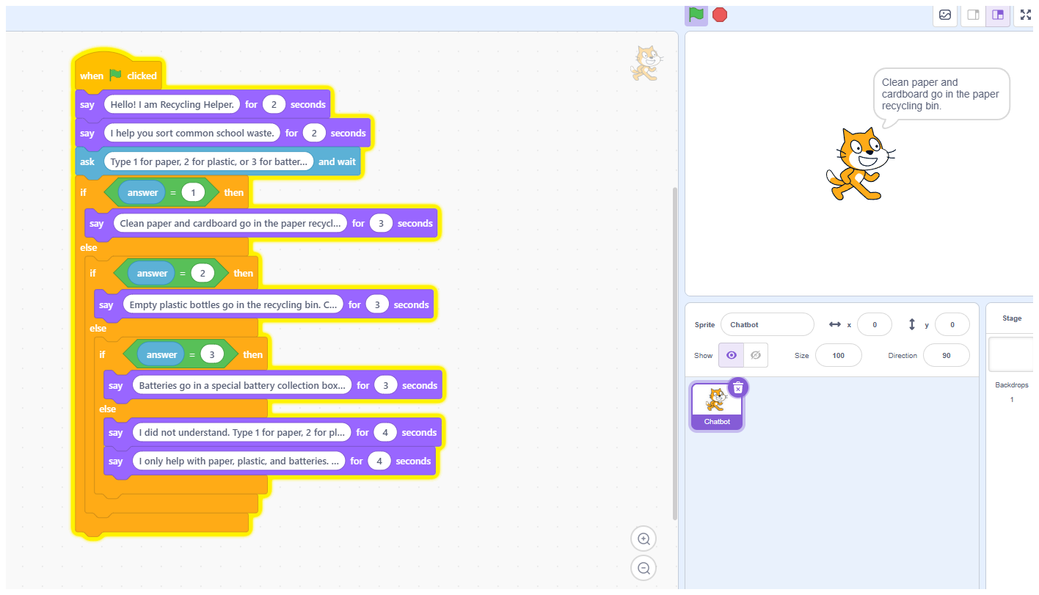
Figure 2. The transferred principle test produces observable Scratch behaviour.
Use the exact test transferred on the Handover Card. Record the input and the exact response shown on the stage. Judge the visible behaviour, not the Scratch comment or the creators’ intention.

Mission 2 - Fresh User Challenge
Create one safe new input, such as 4, help, a misspelled choice, a different wording, or an outside-scope question. Record whether the user receives clear recovery or limitation guidance.

Optional - Expected-use test
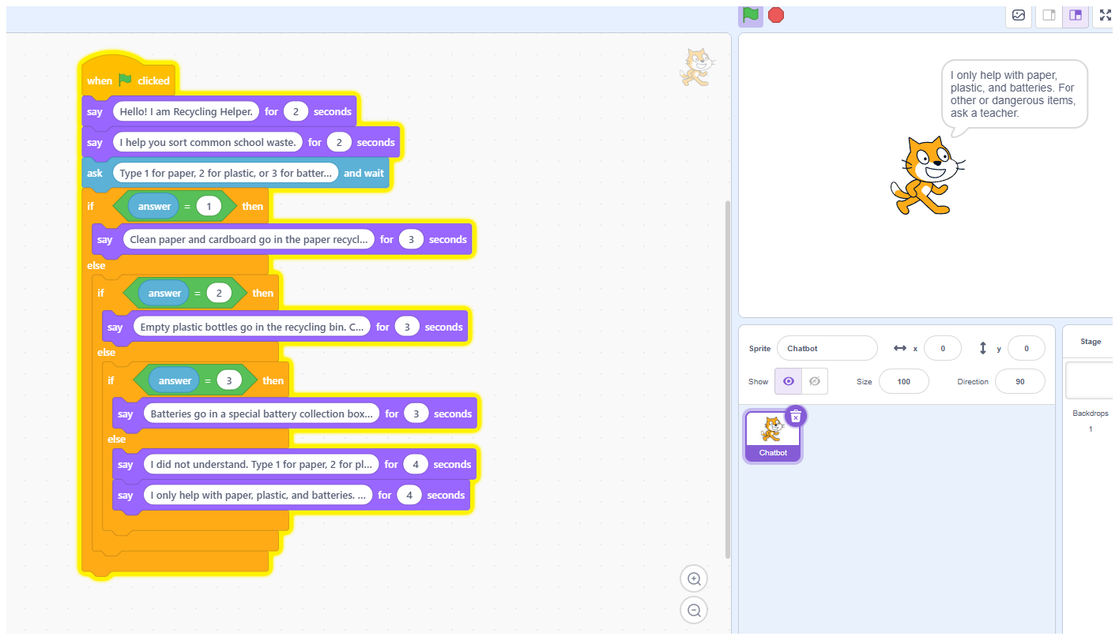
Figure 3. An optional planned input checks one normal response branch.
Use one unused suggested question or menu choice only if time allows. This is optional because the principle test and Fresh User Challenge are the required independent evidence.
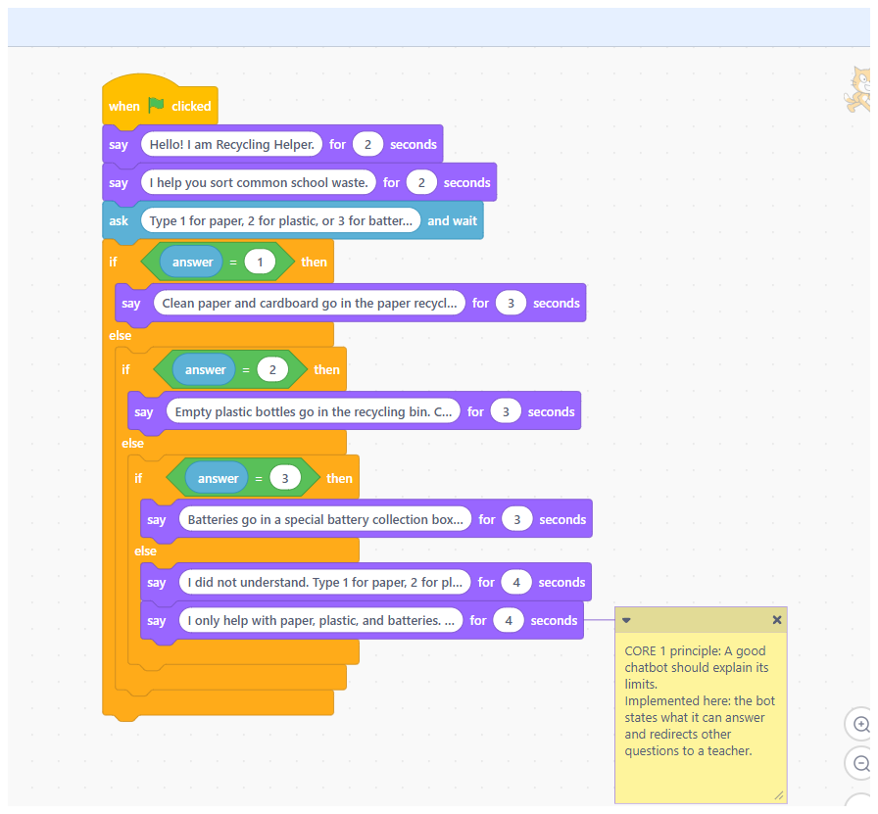
Figure 4. The Scratch comment helps locate the intended feature, but the stage behaviour remains the evidence.

Interpreting the Fresh User Challenge
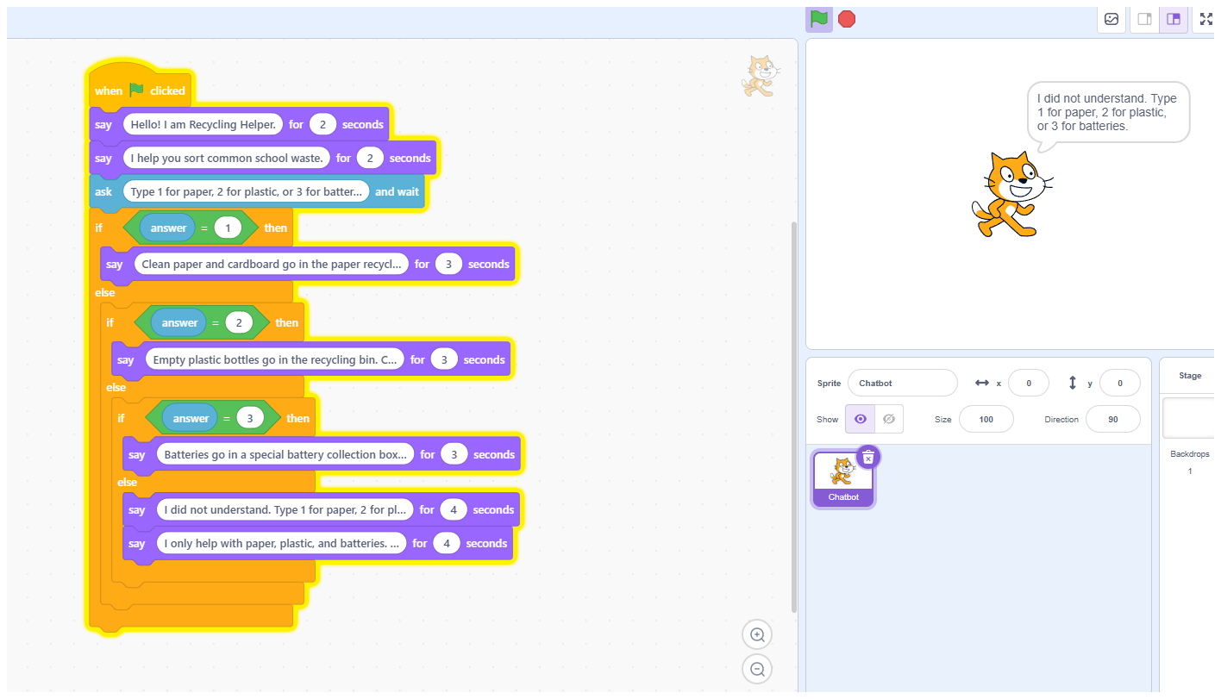
Figure 5. Unsupported input reveals whether fallback behaviour helps the user recover.
The aim is not to trick the chatbot. The challenge should show whether a new user understands what happened, how to continue, and where the chatbot limits begin.

Write evidence, not opinions
Weak feedback | Evidence-based feedback
“It was good.” | “We entered 1. The chatbot gave the paper response and it matched the menu category. Judgement: Yes.”
“The fallback is bad.” | “We entered 4. The chatbot first listed the valid choices and then showed a separate limitation message. The guidance was correct, but it was split across two messages. Judgement: Partly.”
“The principle works.” | “We asked the transferred outside-scope question. The chatbot stated its limits and redirected us to a teacher. Principle: Confirmed.”

Make one evidence-based revision decision
Decision level | Choose this when... | Typical Scratch action
Improve - essential | The chatbot misleads, gives the wrong branch, hides its limits or provides unsafe guidance. | Revise a comparison block, final else branch, fallback or limitation response.
Improve - helpful | The response is correct but unclear, vague, too broad or difficult for the target user. | Revise one say block, introduction or category wording.
Keep as designed | Both mandatory tests provide clear evidence that the feature works for the intended user and scope. | Do not change the code. Record the reason and run a confirmation test.

Act on the decision: Improve or Keep as designed
If the evidence reveals a meaningful issue, locate the exact block connected to it and change only what is needed. If the tested feature already works well, keep it as designed and record the evidence-based reason. Do not add a cosmetic change simply to show activity.
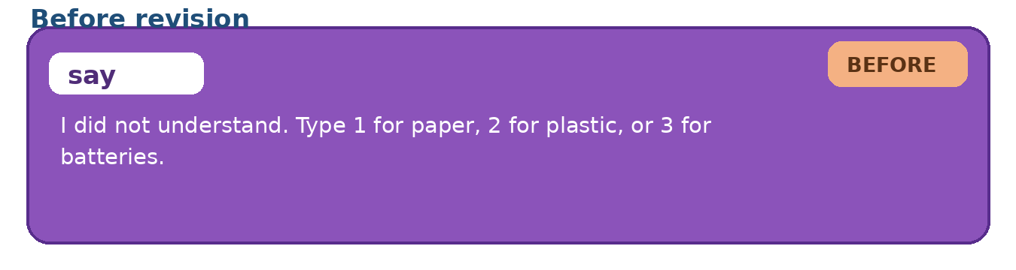
Figure 6. Before revision: recovery and outside-scope guidance are split across two consecutive messages.
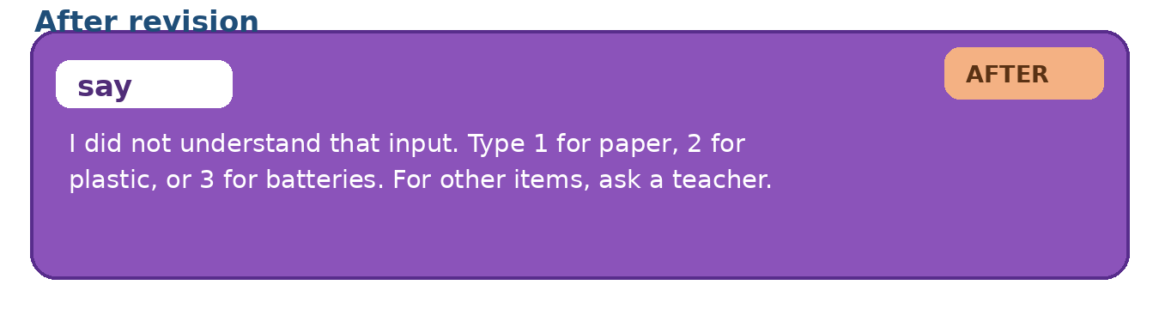
Figure 7. After revision: one combined message gives recovery guidance and redirects unsupported questions.
Before | After | Why this is better
Message 1: “I did not understand. Type 1 for paper, 2 for plastic, or 3 for batteries.”  Message 2: “I only help with paper, plastic, and batteries. For other or dangerous items, ask a teacher.” | I did not understand that input. Type 1 for paper, 2 for plastic, or 3 for batteries. For other items, ask a teacher. | It keeps the recovery and scope guidance but presents it once, more quickly and clearly for a new user.

Verify the revision decision
1. After Improve, use the exact input that revealed the issue.
2. After Keep as designed, use one unused suggested question or a second safe wording as a confirmation test.
3. Click the green flag before the verification test.
4. Record the final behaviour.
5. Judge the result as Fixed / Partly fixed / Not fixed, or Confirmed / Not confirmed.
Why the verification must match the decision
A same-input re-test shows whether an identified problem improved. A confirmation test checks whether a Keep decision remains credible under one additional safe input.

Common Scratch problems during CORE 3
Problem | Likely cause | Teacher response
The project does not reset | Students did not click the green flag before the re-test. | Restart consistently before every comparison.
The wrong response appears | A comparison operator or nested if/else branch was changed incorrectly. | Test 1, 2 and 3 separately and inspect answer comparisons.
Fallback and limitation are mixed | The final else contains only one vague message. | Separate recovery guidance from scope/safety guidance.
Students force a change even though the feature works | They think every test must produce a revision. | Allow Keep as designed when evidence supports it; require a confirmation test.
The comment says the principle works but behaviour does not | Intended design is being treated as evidence. | Run the exact principle test and judge the stage output.
Screenshot contains account data | The full browser window was captured. | Crop or recapture before saving or sharing.

Final Scratch evidence package
· final .sb3 file or project link, revised only when needed;
· completed CORE 3 Test-Decide-Confirm Card;
· before-and-after evidence when a change was made;
· re-test or confirmation-test result;
· final CORE 1 principle validation;
· no personal data in screenshots or filenames.
Recommended teacher message
“Do not add more features and do not force a change. Use the evidence to choose Improve or Keep, then verify that decision.”

